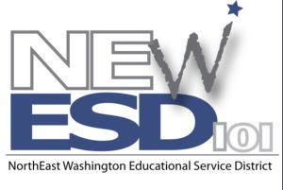
CONSORTIUM
Teacher Evaluation

Interview Protocol for a Preconference
(Lesson Plan)

- To what part of your curriculum does this lesson relate? (1a)

- How does this learning “fit” in the sequence of learning for this class? (1a, 1e)

- Briefly describe the students in this class, including those with special needs. (1b)

- What are your learning outcomes for this lesson? What do you want the students to understand? (1c)

- How will you engage the students in the learning? What will you do? What will the students do? (1e)

- Will the students work individually or as a large group? Provide any worksheets or other materials the students will be using. (1e)

- How will you differentiate instruction for different individuals or groups of students in the class? (1e)

- How and when will you know the students have learned what you intend? (1f)

- Is there anything that you would like me to specifically observe during the lesson?

